# Segment 4: Agent Performance Analysis

* Company wants to provide a performance bonus to their best agents based on the maximum order amount. Find the top 5 agents eligible for it.

# 

* The company wants to analyse the performance of agents based on the number of orders they have handled. Write a SQL query to rank agents based on the total number of orders they have processed. Display agent_name, total_orders, and their respective ranking.
* 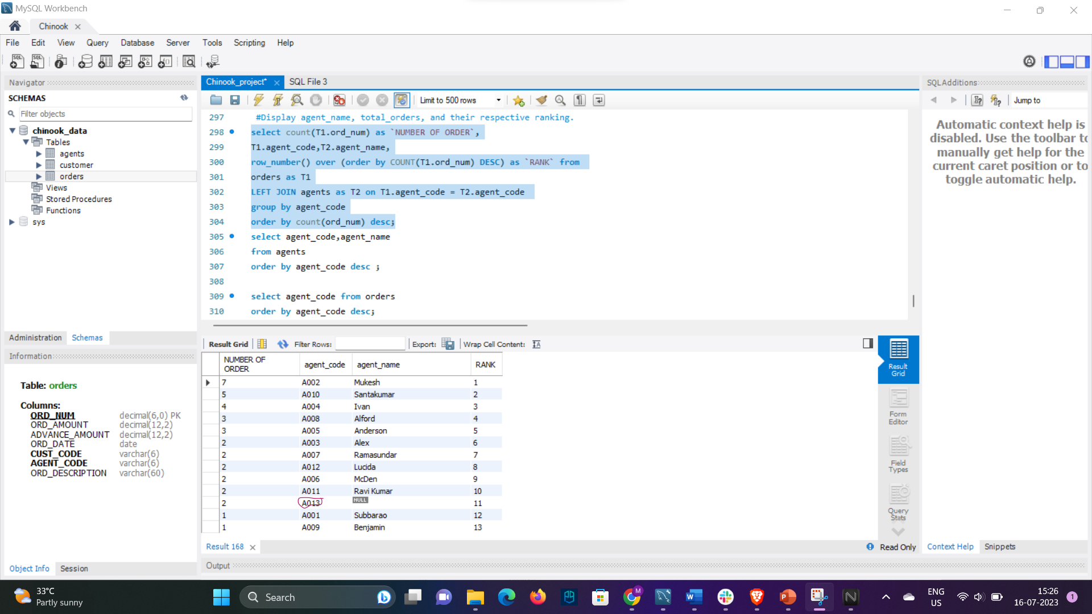
* Company wants to change the commission for the agents, basis advance payment they collected. Write a sql query which creates a new column updated_commision on the basis below rules.
  + If the average advance amount collected is less than 750, there is no change in commission.
  + If the average advance amount collected is between 750 and 1000 (inclusive), the new commission will be 1.5 times the old commission.
  + If the average advance amount collected is more than 1000, the new commission will be 2 times the old commission.



